**Program Documentation for aver_per_sim_2_haplos.py**

Contents

Files linked to *aver_per_sim_2_haplo2.py* 1

Overview of processing steps 2

# Files linked to *aver_per_sim_2_haplo2.py*

Figure 1 shows the file dependencies of python program *aver_per_sim_2_haplos.py* and figure 2 the dependencies of various tools associated with this program.

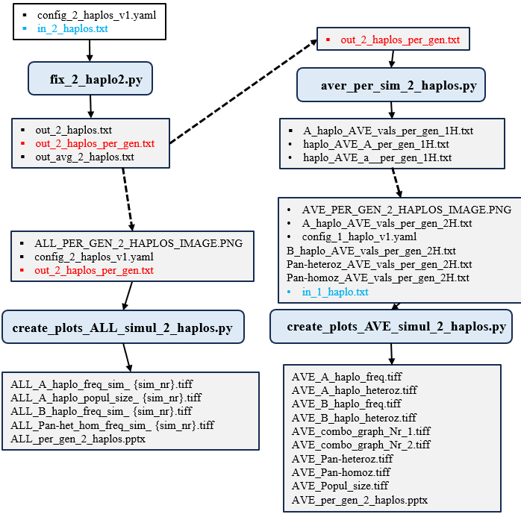

**Figure 1**. Input and output file dependencies for python program *aver_per_sim_2_haplo2.py*.

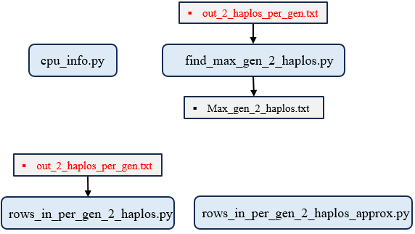

**Figure 2**. Input and output file dependencies for additional tools.

# Overview of processing steps

**Steps the program executes chronologically**

1. Import necessary Python modules including csv, os, collections, time, concurrent.futures, multiprocessing, and sys.

2. Record the program start time.

3. Prevent system sleep on Windows using Windows API calls.

4. Define a function process_roll_forward_and_average_streaming that computes time-averaged statistics across simulation runs for a specified target column (e.g., heterozygosity), using roll-forward logic to handle post-fixation values.

5. Define a helper function format_row that formats averaged results into output-ready strings with proper decimal precision.

6. Define a worker function process_one_sim_nr that reads per-generation data for a single SimNr from the input file.

7. In process_one_sim_nr, parse the input file header to build a column index mapping.

8. Convert each data row to appropriate types (int, float, or str) based on column semantics.

9. Filter rows belonging to the target SimNr, leveraging early exit assuming the input is sorted by SimNr.

10. Validate that all required columns are present; skip processing if any are missing.

11. For each of four metrics (freq_Aa, freq_Bb, pan_heteroz, pan_homoz), apply the corresponding fixation condition and compute averaged time-series using process_roll_forward_and_average_streaming.

12. Format the results for each metric and return them in a dictionary grouped by target column.

13. In the main function, verify that the input file "out_2_haplos_per_gen.txt" exists.

14. Scan the input file to collect all unique SimNr values while enforcing strict ascending order; abort if order is violated.

15. Sort the SimNr list for consistent processing.

16. Define output filenames and their corresponding headers for four result types.

17. Prepare an output specification mapping each metric to its output file.

18. Initialize all four output files with their respective headers.

19. Create a list of arguments for parallel processing, one per SimNr.

20. Set the multiprocessing start method to 'spawn' for cross-platform compatibility.

21. Launch parallel workers using ProcessPoolExecutor to process each SimNr independently.

22. Collect all results from workers into a dictionary keyed by SimNr and metric.

23. After all workers complete, write results to each output file in strict SimNr order to ensure reproducibility.

24. Print the names of all generated output files.

25. Print the current working directory.

26. Print the total program execution time.